Sequence types:

* Sequence types aggregate individual items into ordered collections of items.
* 4 common: strings lists tuples and ranges
* They share terminology: it is reasonable to talk about the length of any item of type string, list, tuple or range in exactly the same manner
* Strings are ordered sequences of characters(in Python, characters are just strings of length 1) enclosed in either single or double quotes
* Strings contain some normal characters , but also contain some unusual unprintable characters or characters from different alphabets.
* ‘This is a test’, 14 characters in it
* ‘a b c’
* ‘I don’t know’ #error “I don’;t know” #no error
* ‘ ‘ does not equal “
* ‘\t’ tab
* ‘\n’ newlone
* ‘ \r ‘ carriage return Returning carriage and goes newline
* ‘\’ ‘ embedded quote
* ‘ \ \ ‘ backward slash
* ***There is a difference between a value and its printed representation:***
* >>> “this\tthat”
* ‘This\tthat’ REPL provides value
* print( “this\tthat””)
* This that

STrings have own set of operations:

* 
* 
* 
* The operator ***in*** are specific to strings( and sequences in general).
* 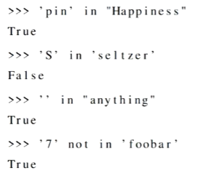

Tuple:

* Python allows you to aggregate items (of any type) into a collection called a tuple
* Tuples are (almost always) enclosed in parentheses, and items are separated by commas (every non-empty tuple requires at least one comma; why?).
* 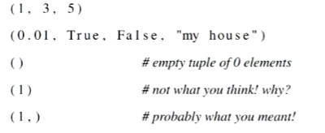
* Yeah
* 
 